

**Year 11 Unit 1 Examination, 2018**

**Question/Answer Booklet**

**CHEMISTRY**

Student Name: **ANSWERS**

Teacher Name: ______________________________________________

#### Time allowed for this paper

Reading time before commencing work: ten minutes

Working time for paper: two and a half hours

**Materials required/recommended for this paper**

***To be provided by the supervisor***

This Question/Answer Booklet

Multiple-choice Answer Sheet

Chemistry Data Sheet

***To be provided by the candidate***

Standard items: pens (blue/black preferred), pencils (including coloured), sharpener, correction tape/fluid, eraser, ruler, highlighters

Special items: up to three non-programmable calculators approved for use in the ATAR examinations

**Important note to candidates**

No other items may be taken into the examination room. It is your responsibility to ensure that you do not have any unauthorised notes or other items of a non‑personal nature in the examination room. If you have any unauthorised material with you, hand it to the supervisor before reading any further.

**Structure of this paper**

|  |  |  |  |  |  |
| --- | --- | --- | --- | --- | --- |
| Section | Number of questions available | Number of questions to be answered | Suggested working time  (minutes) | Marks available | Percentage of examination |
| Section One:  Multiple-choice | 20 | 20 | 40 | 40 | 25.0 % |
| Section Two:  Short answer | 8 | 8 | 50 | 58 | 32.25 % |
| Section Three:  Extended answer | 6 | 6 | 60 | 62 | 38.75 % |
| **Total** | | | | | 100.0 % |

**Instructions to candidates**

1. Answer the questions according to the following instructions.

Section One: Answer all questions on the separate Multiple-choice Answer Sheet provided. For each question shade the box to indicate your answer. Use only a blue or black pen to shade the boxes. If you make a mistake, place a cross through that square, do not erase or use correction fluid, and shade your new answer. Marks will not be deducted for incorrect answers. No marks will be given if more than one answer is completed for any question.

Sections Two and Three: Write answers in this Question/Answer Booklet.

3. When calculating numerical answers, show your working or reasoning clearly. Express numerical answers to the appropriate number ofsignificant figures and include appropriate units where applicable

4. You must be careful to confine your responses to the specific questions asked and to follow any instructions that are specific to a particular question.

5. Spare pages are included at the end of this booklet. They can be used for planning your responses and/or as additional space if required to continue an answer.

• Planning: If you use the spare pages for planning, indicate this clearly at the top of the page.

• Continuing an answer: If you need to use the space to continue an answer, indicate in the original answer space where the answer is continued, i.e. give the page number. Fill in the number of the question that you are continuing to answer at the top of the page.

**Multiple-Choice Questions: ANSWERS**

|  |  |
| --- | --- |
| **Question** | **Answer** |
| 1 | B |
| 2 | A |
| 3 | C |
| 4 | C |
| 5 | D |
| 6 | D |
| 7 | D |
| 8 | C |
| 9 | A |
| 10 | D |
| 11 | D |
| 12 | D |
| 13 | B |
| 14 | B |
| 15 | C |
| 16 | A |
| 17 | C |
| 18 | C |
| 19 | A |
| 20 | D |

**Section One: Multiple-choice 25% (40 Marks)**

This section has **20** questions. Answer **all** questions on the separate Multiple-choice Answer Sheet provided. For each question shade the box to indicate your answer. Use only a blue or black pen to shade the boxes. If you make a mistake, place a cross through that square, do not erase or use correction fluid, and shade your new answer. Marks will not be deducted for incorrect answers. No marks will be given if more than one answer is completed for any question.

Suggested working time: 40 minutes.

1. Which of the following are homogeneous mixtures?

i sodium chloride

ii. white vinegar

iii. white wine

iv. baked beans

1. i and iii only
2. ii and iii only
3. iii and iv only
4. ii, iii and iv only

2. A covalent bond would be expected to form between atoms which have the electron configurations

1. 2,7 and 2,6.
2. 2,8,8 and 2.
3. 2,8,1 and 2,8,7.
4. 2,8,5 and 2,8,8,1.

3. Which one of the following descriptions relates correctly to an ionic solid?

(a) an ordered lattice arrangement of cations and free valence electrons

(b) a crystalline form that is hard and has lustre

(c) a high melting point due to strong electrostatic interaction

(d) valence electrons are free to conduct charge

4. Which one of the following compounds contains only ionic bonds?

(a) CH3COOH

(b) HCl

(c) NaH

(d) NaNO3

5. Which one of the following statements best describes a covalent bond?

1. The atoms have a noble gas configuration.
2. The atoms have formed an infinite network.
3. One of the atoms involved in the bond is a metal and the other is a non-metal.
4. There is simultaneous attraction of both nuclei to a shared electron pair.

6. Which one of the following characteristics does not apply to solutions?

1. They are homogeneous mixtures.
2. They contain two or more substances.
3. They have uniform composition.
4. They always contain a solid that has dissolved in a liquid

7. Which one of the following statements about elements in Groups 1 and 2 on the Periodic Table is correct?

1. They can only become positively charged and form strong covalent molecules.
2. They form negative ions because they have few valence electrons.
3. They can share electrons to form positive ions.
4. They can form positive ions because they have loosely held valence electrons.

8. Use the table to identify a pair of isotopes.

|  |  |  |  |
| --- | --- | --- | --- |
| Element | No. of Protons | No. of Electrons | No. of Neutrons |
| W | 20 | 21 | 21 |
| X | 19 | 18 | 19 |
| Y | 19 | 21 | 19 |
| Z | 20 | 19 | 20 |

1. Elements X and W
2. Elements X and Y
3. Elements W and Z
4. Elements Y and W

9. Which one of the following correctly classifies the substances listed?

|  |  |  |  |  |
| --- | --- | --- | --- | --- |
|  | Covalent molecular | Ionic | Covalent Network | Metallic |
| (a) | C6H12O6 | KBr | SiC | Mg |
| (b) | KNO3 | CaCO3 | CO2 | Brass |
| (c) | CO2 | NH4C | C2 | Ca |
| (d) | NH4C | NaC | C | Fe |

10. Which one of the following statements about nanomaterials is **false**?

(a) Nanomaterials are substances that contain particles with specific properties which may differ from those of the equivalent bulk material.

(b) Nanomaterials are materials made of nano-particles which range from 1 – 100 nm in size.

(c) Fullerene, an allotrope of carbon, can be used to make nanomaterials.

(d) Nanomaterials are substances that contain only particles of 1 nm in size.

11. Which one of the following is the correct formula for magnesium phosphate?

(a) MgPO4

(b) Mg3(PO)4

(c) Mg2PO2

(d) Mg3(PO4)2

12. Which of the following is the electronic configuration for the Phosphide Ion, P3-?

(a) 1s2 2s2 3s6 2p2 3p6

(b) 1s2 2s2 2p6 3s2 3p4

(c) 1s2 2s2 2p6 3s2 3p2

(d) 1s2 2s2 2p6 3s2 3p6

13. Which one of following is the best explanation as to why ionic substances conduct electricity in both the molten and aqueous form?

1. Ionic bonding is similar to metallic bonding in that when molten and aqueous they both have freely moving electrons.
2. In both the molten and aqueous solution ionic substances have mobile ions.
3. In both the molten and aqueous solution ionic substances have mobile electrons
4. Ionic substances have high melting points and are brittle.

14. Separating pure water from sea water can be done simply by:

(a) evaporation.

(b) distillation.

(c) decantation.

(d) filtration.

15. Which two of these species represent an element, and its positive ion?

|  |  |  |  |
| --- | --- | --- | --- |
| Species | Number of protons | Number of electrons | Number of neutrons |
| 1 | 37 | 37 | 38 |
| 2 | 38 | 38 | 38 |
| 3 | 38 | 36 | 41 |
| 4 | 37 | 37 | 41 |

(a) 1 and 2

(b) 1 and 3

(c) 2 and 3

(d) 2 and 4

16. Which of the following has the molecules in order of **decreasing** bond polarity?

(a) HF, HCℓ, CH4, H2

(b) HCℓ, HF, CH4, H2

(c) CH4, H2, HCℓ, HF

(d) H2, CH4, HCℓ, HF

17. Which of the following statements is the best description of the trends in the 1st ionisation energy of the elements on the Periodic Table?

(a) 1st ionisation energy increases across Period 3 and increases down groups of the Periodic Table.

(b) 1st ionisation energy decreases across Period 3 and decreases down groups of the Periodic Table.

(c) 1st ionisation energy increases across Period 3 and decreases down groups of the Periodic Table.

(d) 1st ionisation energy decreases across Period 3 and increases down groups of the Periodic Table.

18. Identify all of the types of bonding present in a solution of nickel(II) chloride in ethanol.   
  
 I dispersion forces  
 II ion-dipole forces  
 III hydrogen bonds  
 IV ionic bonds

(a) II and IV

(b) I, III and IV

(c) I, II, and III

(d) All of the above.

19. Which of the following groups of solutions will produce a coloured precipitate when mixed?   
  
All solutions are 0.1 mol L-1.

(a) Potassium hydroxide Copper(II) sulfate Calcium bromide

(b) Copper(II) sulfate Sodium chloride Barium nitrate

(c) Strontium bromide Iron(III) nitrate Sodium iodide

(d) Ammonium nitrate Iron(II) chloride Potassium sulfate

20. Substance A is made up three components (G, B and R). A small sample of substance A was dotted onto chromatography paper, and a chromatogram was developed using an appropriate solvent.

G has moved the most while B is in the middle and R is the lowest spot.in the result that is shown below.

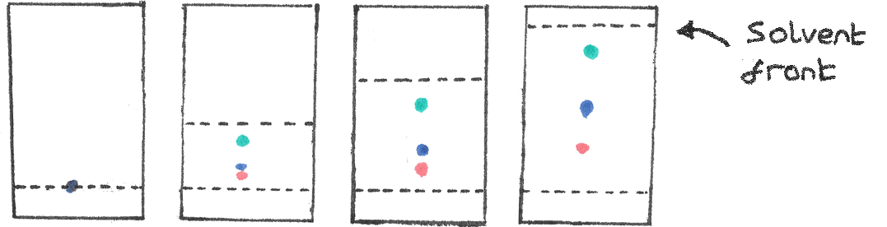

Compound G is adsorbed

(a) more strongly onto the stationary phase and has a smaller Rf value than component B.

(b) more strongly onto the stationary phase and has a larger Rf value than component B.

(c) less strongly onto the stationary phase and has a smaller Rf value than component B.

(d) less strongly onto the stationary phase and has a larger Rf value than component B.

**End of Section One**

**Section Two: Short answer 36.2% (58 Marks)**

This section has **8** questions. Answer **all** questions. Write your answers in the spaces provided.

When calculating numerical answers, show your working or reasoning clearly. Express numerical answers to the appropriate number of significant figures and include appropriate units where applicable.

Spare pages are included at the end of this booklet. They can be used for planning your responses and/or as additional space if required to continue an answer.

• Planning: If you use the spare pages for planning, indicate this clearly at the top of the

page.

• Continuing an answer: If you need to use the space to continue an answer, indicate in

the original answer space where the answer is continued, i.e. give the page number. Fill in the number of the question(s) that you are continuing to answer at the top of the page.

Suggested working time: 50 minutes.

**Question 21 (6 marks)**

(a) Write the formulae of each of the following compounds. (3 marks)

|  |  |
| --- | --- |
| **Name** | **Formula** |
| Calcium hydrogen carbonate | **Ca(HCO3)2** |
| Vanadium (IV) bromide | **VBr4** |
| Phosphorus pentoxide | **PO5** |

|  |  |
| --- | --- |
| **Description** | **Marks** |
| Formula completely correct | 1 each |

(b) Write the names of each of the following species. (3 marks)

|  |  |
| --- | --- |
| **Formula** | **Name** |
| SO42- | **Sulfate Ion (“Ion” is optional)** |
| Li2O | **Lithium Oxide** |
| Cu(OH)2 | **Copper(II) Hydroxide (must include “(II)”)** |

|  |  |
| --- | --- |
| **Description** | **Marks** |
| Name completely correct | 1 each |

**Question 22 (9 marks)**

Draw the Lewis structures for the following substances, showing all valence electrons. State whether each substance is polar or non-polar.

|  |  |  |
| --- | --- | --- |
| **Substance** | **Lewis Structure** | **Polarity** |
| Silicon dioxide | **1 mark for bonds, 1 mark for lone pairs** | **Not Polar**  **1 mark** |
| Carbon tetrafluoride | http://www.chemeddl.org/resources/models360/data/cf4.png  **1 mark for bonds, 1 mark for lone pairs** | **Not Polar**  **1 mark** |
| Nitrogen triiodide | See the source image  **1 mark for bonds, 1 mark for lone pairs** | **Polar**  **1 mark** |

|  |  |
| --- | --- |
| **Description** | **Marks** |
| Correct Lewis structure showing all bonding pairs and lone pairs | 2 per molecule |
| Lewis structure with correct bonding pairs but incorrect / missing lone pairs  OR  Lewis structure with incorrect bonding pairs, but lone pairs drawn correctly for the molecule drawn | 1 per molecule |
| Molecules described as polar | 1 per molecule |
| **TOTAL**  Note : bonding pairs can be drawn as a single lines not two dots | **9** |

**Question 23 (11 marks)**

Five unlabelled solutions are known to be; sodium sulfate, sodium iodide, sodium carbonate, sodium nitrate, barium hydroxide.

These 5 solutions are randomly labelled V, W, X, Y, Z and samples are tested with reagents. These tests are described in the table below.

|  |  |  |  |  |  |
| --- | --- | --- | --- | --- | --- |
|  | Solutions | | | | |
| Reagents | V | W | X | Y | Z |
| Mg(NO3)2 | no visible reaction | no visible reaction | no visible reaction | white ppt | white ppt |
| Ba(NO3)2 | no visible reaction | no visible reaction | white ppt | white ppt | no visible reaction |
| Pb(NO3)2 | no visible reaction | yellow ppt | white ppt | white ppt | white ppt |

In the space below deduce what can be inferred about the identity of the samples when each of the reagents are used.

1. Mg(NO3)2 (3 marks)

|  |  |
| --- | --- |
| **Description** | **Marks** |
| Y and Z have contain anions that form insoluble precipitates with Mg ions | 1 |
| V, W and X contain anions that form soluble solution with Mg ions | 1 |
| All precipitates containing Mg are white | 1 |
| **TOTAL** | 3 |

1. Ba(NO3)2 (3 marks)

|  |  |
| --- | --- |
| **Description** | **Marks** |
| X and Y contain anions that are form insoluble precipitates with Ba ions | 1 |
| V, W and Z contain anions that form soluble solution with Ba ions | 1 |
| All Precipitates containing Ba are white | 1 |
| **TOTAL** | 3 |

1. Pb(NO3)2 (3 marks)

|  |  |
| --- | --- |
| **Description** | **Marks** |
| W, X , Y and Z contain anions that are form insoluble precipitates with Pb ions | 1 |
| Only V contain anions that form soluble solution with Pb ions | 1 |
| While most precipitates containing Pb are white, the yellow ppt indicates PbI(s) | 1 |
| **TOTAL** | 3 |

1. Identify the solutions: (2 marks)

|  |  |  |  |  |  |
| --- | --- | --- | --- | --- | --- |
| Sample | V | W | X | Y | Z |
| Identify of Solution: | **Sodium Nitrate** | **Sodium Iodide** | **Sodium Sulfate** | **Sodium Carbonate** | **Barium Hydroxide** |

|  |  |
| --- | --- |
| **Description** | **Marks** |
| All correct | 2 |
| One incorrect | 1 |
| More than one incorrect | 0 |
| **TOTAL** | 3 |

**Question 24 (4 marks)**

Using a labelled diagram, show how ion-dipole forces are formed when potassium chloride dissolves in water.

|  |
| --- |
| **Example Diagram:**  See the source image |

|  |  |
| --- | --- |
| **Description** | **Marks** |
| Must have a diagram that clearly shows: |  |
| Two lone pair of electron on to Oxygen atom | 1 |
| Dipole moments of the water molecule ie delta +ve on the Hydrogen atom and delta -ve on the oxygen atom | 1 |
| Bent shape of water molecule | 1 |
| Interaction between the +ve moments water molecule and -ve chloride ion  AND  Interact between the -ve moments of the water molecule and the +ve potassium ion  (note: interactions can be shown as dashed lines for dashed bars but not solid lines indicating full bonds) | 1 |
| Any explanation that contradicts the diagram or that is incorrect – deduct ONE mark |  |
| **Total** | **4** |

**Question 25 (9 marks)**

The diagram below shows a **Mass Spectrometry** apparatus being used to analyse a sample of chlorine, which contains the isotopes chlorine-35 and chlorine-37.

**Results**

37Cl

Injection of vapourised sample

Positively charged plates (+)

**A**

**B**

Ions

Magnetic field

**C**

Negatively charged plates (­–)

Beam of electrons

Detector

35Cl

**D**

85.0%

Relative Abundance

15.0%

(a) Ionisation of chlorine atoms occurs at **A**. Explain what is meant by the term ionisation in this situation. In your answer explain why energy is required for ionisation to occur.

(2 marks)

|  |  |
| --- | --- |
| **Description** | **Marks** |
| The loss of an electron(s) from an atom | 1 |
| Energy required to overcome the attraction of the (negative) electron(s) to the (positive) nucleus | 1 |
| **Total** | **2** |

* 1. Write the formula of the ions present at **B**.

(1 mark)

|  |  |
| --- | --- |
| **Description** | **Marks** |
| C+ | 1 |
| **Total** | **1** |

(c) (i) The ions of which isotope are present at **C**? (1 mark)

|  |  |
| --- | --- |
| **Description** | **Marks** |
| Chlorine-35+  OR 35C+  Must have charge | 1 |
| **Total** | **1** |

(ii) Explain you answer to part (c) (i). (2 marks)

|  |  |
| --- | --- |
| **Description** | **Marks** |
| They are lighter and deflected more | 2 |
| **Total** | **2** |

1. Use the results shown to calculate the relative atomic mass (atomic weight) of this sample of chlorine.

(2 marks)

|  |  |
| --- | --- |
| **Description** | **Marks** |
| Mw(Cl) = (85 x 35 + 15 x 37) / 100 | 1 |
| = 35.3 | 1 |
| **Total** | **2** |

1. Explain why this sample is probably not naturally occurring chlorine.

(1 mark)

|  |  |
| --- | --- |
| **Description** | **Marks** |
| This sample has an average molecular mass of less than molecular mass of a naturally occurring population of chlorine atoms (35.45). | 1 |
| Notes:  There is a lesser abundance of Cl-37 isotopes (or greater Cl-35 isotopes) in this sample than naturally occurring population of chlorine atoms |  |

**Question 26 (5 marks)**

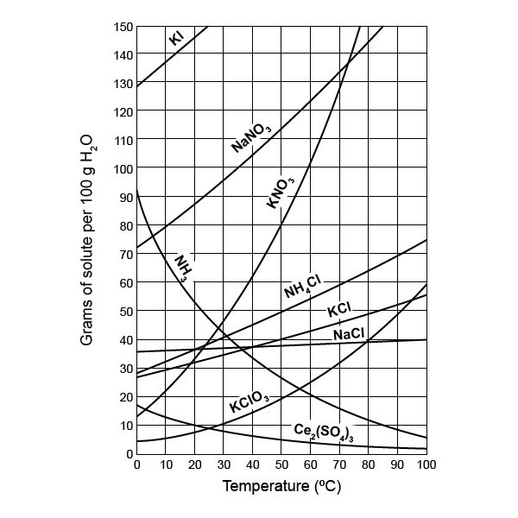

(a) Use the graph above to estimate the solubility of: (2 marks)  
  
 (i) Potassium nitrate at 55 oC.

|  |  |
| --- | --- |
| **Description** | **Marks** |
| 90g | 1 |

(ii) Ammonia at 70 oC.

|  |  |
| --- | --- |
| **Description** | **Marks** |
| 17g  (Accept 16g, 17g or 18g) | 1 |

(b) If a solution of potassium nitrate is described as 5.5 g L-1, calculate the concentration in mol L-1. (1 mark)

|  |  |
| --- | --- |
| **Description** | **Marks** |
| Conc (mol L-1) = 5.5/101.11 = 0.054 mol L-1  (no penalty for omitting units) | 1 |
| **Total** | **1** |

(c) Explain the difference between the terms saturated and unsaturated, with reference to the data for a solution of sodium nitrate at 30 oC. (2 marks)

|  |  |
| --- | --- |
| **Description** | **Marks** |
| Unsaturated is less than 95g of sodium nitrate dissolved in 100g of water | 1 |
| Saturated is EXACTLY 95g of sodium nitrate dissolved in 100g of water | 1 |
| **Total** | **2** |

**Question 27 (5 marks)**

Consider the information about some pure substances.

|  |  |  |  |  |  |
| --- | --- | --- | --- | --- | --- |
| Substance | Melting point (oC) | Boiling point  (oC) | Electrical conductivity in solid state | Electrical conductivity in liquid state | Solubility in water |
| 1 | 1535 | 2750 | good | good | insoluble |
| 2 | 800 | 1410 | non | good | soluble |
| 3 | -259 | -253 | non | non | insoluble |
| 4 | 1710 | 2590 | non | non | insoluble |
| 5 | 50 | 265 | non | non | insoluble |

1. Which **one** of the substances above is most likely a **gas** at room temperature?

(1 mark)

__________________________________________________________________________________________

(b) Which **one** of the substances above is most likely to be a **covalent molecular solid**? (1 mark)  
  
__________________________________________________________________________________________

(c) Which **one** of the substances above is most likely to be a **metal**? (1 mark)  
  
  
__________________________________________________________________________________________

(d) Which **one** of the substances above is most likely a **covalent network** substance? (1 mark)

__________________________________________________________________________________________

(e) Which **one** of the substances above is most likely an **ionic** substance? (1 mark)

__________________________________________________________________________________________

|  |  |
| --- | --- |
| **Description** | **Marks** |
| Correct numbered substance  **(a)3 (b) 5 (c) 1 (d) 4 (e) 2** | 1 each |
| **Total** | **5** |

**Question 28 (6 marks)**

Write ionic equations **including state symbols** the following equations, and describe the observations you would expect to see for each reaction.

(a) Barium nitrate solution is mixed with iron(II) sulfate solution.   
  
Ionic Equation: (2 marks)

**Ba2+ (aq) + SO42- (aq) → BaSO4 (s)**    
  
Observations: (1 mark)

**Clear colourless solution and clear pale green solution are mixed, forms a white precipitate forms.**

(b) Lead(II) nitrate solution is mixed with magnesium iodide solution.

Ionic Equation: (2 marks)

**Pb2+ (aq) + 2 I- (aq) → PbI2 (s)**  
  
Observations: (1 mark)

**Two clear colourless solutions form a yellow precipitate in a clear colourless solution**

(c) Sodium sulfide solution is mixed with silver nitrate solution.

Ionic Equation: (2 marks)

**2Ag+(aq) + S2-(aq) 🡪 Ag2S(s)**  
  
Observations: (1 mark)

**Two clear colourless solutions form a black precipitate in a clear colourless solution**

|  |  |
| --- | --- |
| **Description** | **Marks** |
| Correct ionic equation, with correct state symbols | 2 |
| Correct molecular equation, with correct state symbols  OR  Incorrect ionic equation with correct state symbols  OR  Correct ionic equation with incorrect state symbols | 1 |
| Observation describes the colours (underlined) of reagents and products (solutions and precipitate). | 1 |
| Correct molecular equation with incorrect state symbols  OR  Incorrect molecular equation with correct state symbols | 0 |

**End of Section Two**

**Section Three: Extended answer 38.8 (62 Marks)**

This section contains 6questions. You must answer **all** questions. Write your answers in the spaces provided.

Where questions require an explanation and/or description, marks are awarded for the relevant chemical content and also for coherence and clarity of expression. Lists or dot points are unlikely to gain full marks.

Final answers to calculations should be expressed to the appropriate number ofsignificant figures.

Spare pages are included at the end of this booklet. They can be used for planning your responses and/or as additional space if required to continue an answer.

• Planning: If you use the spare pages for planning, indicate this clearly at the top of the

page.

• Continuing an answer: If you need to use the space to continue an answer, indicate in the original answer space where the answer is continued, i.e. give the page number. Fill in the number of the question(s) that you are continuing to answer at the top of the page.

Suggested working time: 70 minutes.

**Question 29 (7 marks)**

The approximate boiling points of the Group 14, 15, 16 and 17 hydrides are plotted on the graph below.

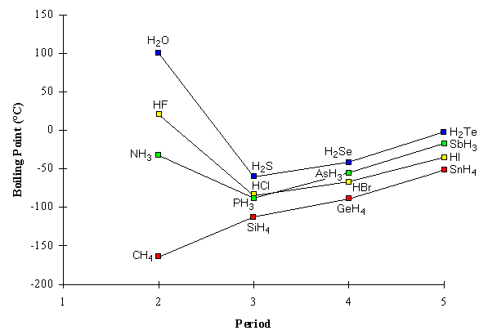

* 1. The hydrides of Group 14 are non-polar molecules. Apply your understanding of intermolecular interactions to explain the steadily increasing boiling points of the Group 14 hydrides CH4, SiH4, GeH4 and SnH4.

(2 marks)

|  |  |
| --- | --- |
| **Description** | **Marks** |
| Increasing mass increases strength of dispersion forces | 1 |
| Increased energy to overcome all intermolecular account for increased boiling points | 1 |
| **Total** | **2** |

1. The Group 15, 16 and 17 hydrides are polar molecules. Consider the Group 17 hydrides HCl, HBr and HI. **List** HCl, HBr and HI in order of **increasing** polarity.

(1 mark)

|  |  |
| --- | --- |
| **Description** | **Marks** |
| HI < HBr < HCl OR HI, HBr, HCl | 1 |
| **Total** | **1** |

1. Compare the trend in polarities of HCl, HBr and HI with the observed trend in their boiling points. Briefly explain your reasoning.

(2 marks)

|  |  |
| --- | --- |
| **Description** | **Marks** |
| Description of trend: Decreasing boiling point as polarity increases | 1 |
| Explanation of trend: Increased energy to overcome higher intermolecular account for increased boiling points due to larger electrostatic forces of attraction. | 1 |
| **Total** | **2** |

1. The first member of each hydride series (NH3 in Group 15, H2O in Group 16, and HF in Group 17) has a much higher boiling point than the next hydride in its series. Apply your understanding of intermolecular interactions to explain the anomalous boiling points of NH3, H2O and HF.

(2 marks)

|  |  |
| --- | --- |
| **Description** | **Marks** |
| Name the Intermolecular Force: Due to presence of hydrogen bonding | 1 |
| Explanation H-bonding: Very large difference in electronegativity between Hydrogen and N,O,F atoms AND the presence of lone pairs of electrons  OR  More energy required to overcome the strong forces. | 1 |
| **Total** | **2** |

**Question 30 (12 marks)**

Diamond and graphite are two allotropes of carbon with distinctly different covalent network structures and physical properties. Compare them in terms of the following points.

(a) Compare the covalent network structures of both diamond and graphite, using a diagram if you wish. (4 marks)

[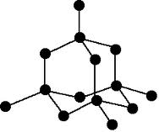](http://www.google.co.uk/url?sa=i&rct=j&q=structure+of+diamond&source=images&cd=&cad=rja&uact=8&docid=pguXl4F7UmjjjM&tbnid=ubpeG7r75PO4qM:&ved=0CAUQjRw&url=http://www.chemguide.co.uk/atoms/structures/giantcov.html&ei=o4gdU47rNcrLhAfL8YCwDw&bvm=bv.62578216,d.ZG4&psig=AFQjCNEyqmIzVlfVtKJbXGbBTU7zJRd4gw&ust=1394530849306660)

[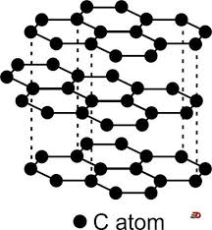](http://www.google.co.uk/url?sa=i&rct=j&q=structure%20of%20graphite&source=images&cd=&cad=rja&uact=8&docid=QtZTGgezLZY66M&tbnid=QJhc4x5--aD6pM:&ved=&url=http://chewtychem.wiki.hci.edu.sg/Giant%2BCovalent%2BStructure&ei=uogdU-q9M9KM7AbN4oCwDw&bvm=bv.62578216,d.ZG4&psig=AFQjCNHPN4znAWXjS1JYN4BbMi3kBJRa9g&ust=1394530875206458)**Diagrams not required, points can be covered with descriptions or labelled diagrams.**

**Diagrams might look a little like these, but as long as the 3D arrangement is clear, can receive some credit.**

|  |  |
| --- | --- |
| **Description** | **Marks** |
| Diamond has each carbon atom covalently bonded to 4 others | 1 |
| Diamond structure is tetrahedral throughout | 1 |
| Graphite has each carbon atom covalently bonded to 3 others in layers | 1 |
| Graphite layers have carbon atoms with a hexagonal arrangement, AND delocalised electrons present | 1 |

(b) Electrical conductivity.

(i) Explain why diamond does not conduct electricity. (2 marks)

|  |  |
| --- | --- |
| **Description** | **Marks** |
| All electrons held in covalent bonds | 1 |
| No charged particles free to **flow / move** to carry current | 1 |

(ii) Explain why graphite does conduct electricity. (2 marks)

|  |  |
| --- | --- |
| **Description** | **Marks** |
| Each carbon atom has one delocalised electron | 1 |
| Delocalised electrons can **flow / move** to carry current | 1 |

(c) Hardness of the solid.

(i) Explain why diamond is so hard. (2 marks)

|  |  |
| --- | --- |
| **Description** | **Marks** |
| All carbon atoms bonded together with **strong** covalent bonds | 1 |
| 3D / tetrahedral lattice is rigid/ lattice extends in 3 dimensions | 1 |

(ii) Explain why graphite is soft. (2 marks)

|  |  |
| --- | --- |
| **Description** | **Marks** |
| Layers of atoms only held together by weak forces of attraction | 1 |
| Layers can slide over each other so graphite is soft | 1 |

**Question 31 (5 marks)**

A solution contains three cations, Ba2+, Cu2+ and Pb2+. The flow chart indicates the plan used to confirm the identity of these cations.

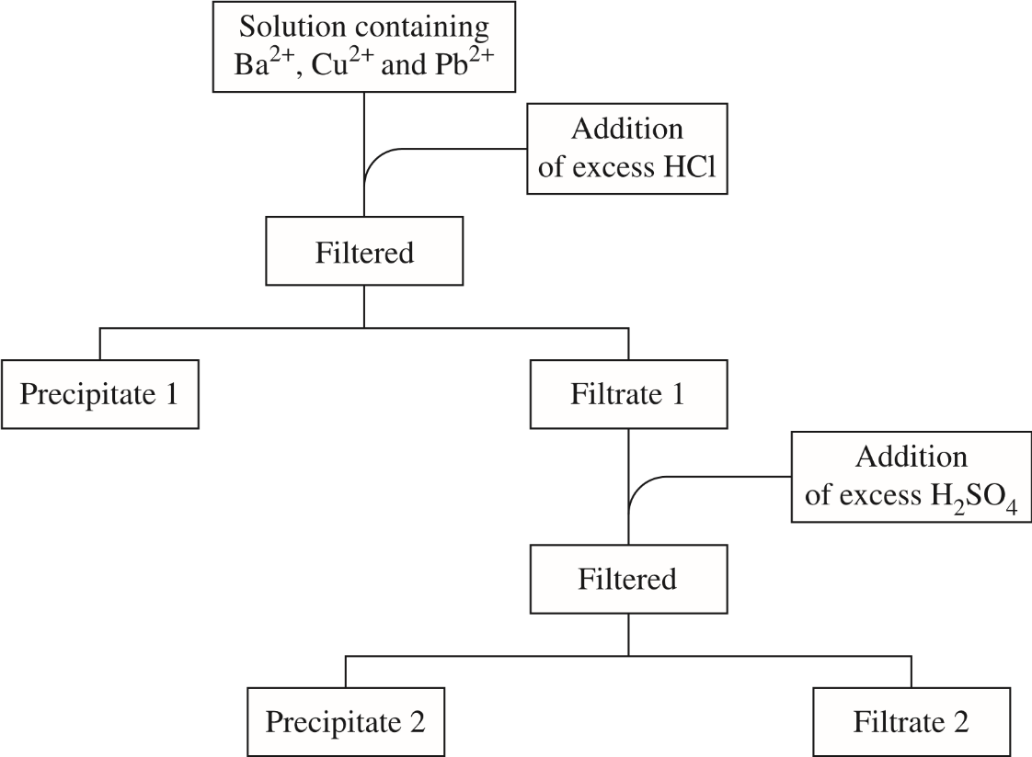

Addition of excess NaOH

1. Name precipitate 2

(1 mark)

|  |  |
| --- | --- |
| **Description** | **Marks** |
| Copper(II) hydroxide | 1 |
| Cu(OH)2 is not acceptable as it is the Formula | 0 |

1. Write a balanced equation for the formation of Precipitate 1

(2 marks)

|  |  |
| --- | --- |
| **Description** | **Marks** |
| Pb2+(aq) + 2Cl-(aq) 🡪 PbCl2(s) | 2 |
| Not balanced or incorrect state symbols | 1 |
| Not balanced AND incorrect state symbols | 0 |

1. Suggest a test and the expected result that would confirm the identity of the metal cation remaining in Filtrate 2.

(2 marks)

|  |  |
| --- | --- |
| **Description** | **Marks** |
| Test Name: Flame test | 1 |
| Expected Result: Flame colour matches (compared) that of a solution known to contain only Barium cations | 1 |
| **Total** | **2** |

**Question 32 (17 marks)**

(a) What was Niels Bohr’s contribution to the understanding of atomic structure?

(2 marks)

|  |  |
| --- | --- |
| **Description** | **Marks** |
| Any two from:   * Only certain energies allowed for each electron * Electrons only found at certain distances / radii * Lowest orbit has lowest energy * Electrons can orbit without losing energy * When electrons drop from higher energy levels to lower energy levels, they emit energy / light / photons * To promote electrons from lower energy levels to higher energy levels, they absorb energy / light / photons | 2 |

(b) How does his contribution contribute to our understanding of analytical techniques such as Flame tests? (3 marks)

|  |  |
| --- | --- |
| **Description** | **Marks** |
| Electrons are excited from lower energy level to higher energy level by heat energy from flame | 1 |
| Electrons drop back from excited state to ground state and **emit** energy / light / photons | 1 |
| Light emitted has characteristic frequencies / wavelength / energy / spectrum / colour, enabling identification of element in flame | 1 |

(c) A drinking water sample was thought to be contaminated with lead(II) ions. The absorbance readings, on an Atomic Absorption Spectrometer, of some **known** samples of lead(II) ions are shown below. Draw a **graph** showing the relationship between lead(II) ion concentration and the absorbance level. (5 marks)

|  |  |
| --- | --- |
| **Concentration of lead(II) ions (mg L-1)** | **Absorbance** |
| 0.0010 | 10 |
| 0.0030 | 35 |
| 0.0070 | 70 |
| 0.010 | 95 |
| 0.013 | 125 |
| 0.016 | 160 |
| 0.020 | 195 |

|  |  |
| --- | --- |
| **Description** | **Marks** |
| Horizontal axis (concentration of lead(II) ions) has label, units, even scale with numbers shown  AND  Vertical axis (absorbance) has label, even scale, number shown | 2 |
| Both axes have some of the above information, but not all parts | 1 |
| Axes wrong way round but otherwise correct | 1 |
| Axes have some information missing AND wrong way round | 0 |
| Graph has a useful title, eg: Absorbance against conc of lead(II) ions | 1 |
| Points plotted accurately | 1 |
| **Straight line** **of best fit** drawn with a ruler, as close as possible to points | 1 |
| **TOTAL**  **Notes:**   * **If points incorrectly plotted and don’t make a straight line, credit can be given for any good line of best fit drawn through the data, as long as it is either one straight line or a smooth curve with no kinks. No credit for dot to dot.** | **5** |

1. The suspect drinking water sample was then tested on the same Atomic Absorption Spectrometer and the absorbance measured at 105. Find the concentration of lead(II) ions, and use this to determine if the water is safe to drink. Briefly show your reasoning on the graph itself or in the space below.

(The maximum acceptable level of lead in drinking water has been established by t National Health and Medical Research Centre at 0.01 mg L-1)

(2 marks)

*Source:* [*https://www.nhmrc.gov.au/guidelines-publications/eh52*](https://www.nhmrc.gov.au/guidelines-publications/eh52)

|  |  |
| --- | --- |
| **Description** | **Marks** |
| Working shown on graph with at least a horizontal line drawn from Abs = 105 to line of best fit, and a vertical line drawn from intersection of horizontal line and line of best fit, to the concentration axis.  OR  Working shown in mathematically, using equation for their line of best fit drawn (eg: y = mx + c, with values for m and c from their line of best fit) | 1 |
| Concentration of lead(II) ions in range 0.01 to 0.011  AND  Water not safe to drink | 1 |
| **TOTAL**  **Note:**   * **If line of best fit is inaccurate, students can get full credit in this question if they show proper working, and give the correct conc of lead(II) for their graph, with the correct conclusion made.** | **2** |

(e) An alternative way to monitor the concentration of contaminants in drinking water is using a precipitation reaction. Barium ions are harmful to health, and the National Health and Medical Research Centre state that they should not be present at a concentration greater than 2 parts per million. A sample of drinking water can be tested for barium ions by adding potassium sulfate solution.

Write an ionic equation for the precipitation reaction that takes place. (1 mark)

**Ba2+ + SO42- → BaSO4**

|  |  |
| --- | --- |
| **Description** | **Marks** |
| Correct ionic equation, state symbols not required | 1 |
| Molecular equation | 0 |

(f) A 2.00 kg sample of drinking water is tested for barium ions by the addition of 100 mL of 1.00 mol L-1 potassium sulfate solution. The mixture is stirred until no more precipitate forms, and the water is evaporated, until only a white solid remains. The mass of solid produced is 5.73 mg.

Assuming all of the white solid is barium sulfate, calculate the concentration of barium in the water sample in parts per million, and determine whether the barium level poses a risk to health.

**Note: Your answer MUST be to the correct number of significant figures**

(4 marks)

|  |  |
| --- | --- |
| **Description** | **Marks** |
| Moles BaSO4 correctly calculated  **Mol BaSO4 = 5.73 x 10-3 / 233.37 = 2.455 x 10-5 mol** | 1 |
| Mass Ba correctly calculated  **Moles Ba = 2.455 x 10-5 mol**  **Mass Ba = 2.455 x 10-5 mol x 137.3 = 3.371 x 10-3 g ( = 3371 mg)** | 1 |
| Conc Ba in ppm correctly calculated to 3sig figs  **Conc Ba = mass of Ba / mass of sample**  **= (3.371 x 10-3) x 106 / 2000**  **= 1.6856 ppm**  **= 1.69 ppm (3sf)** | 1 |
| Correct conclusion drawn  **Water is safe to drink** | 1 |
| **TOTAL**  **Notes:**   * **Concentration of Ba must be to 3sf (Deduct one mark if not)** * **Errors carried forward receive credit for the step, providing working shown clearly, and calculation can be recreated from what is written on the page.** * **Answers to steps 1 & 2 do not need units for the mark, but units need to be correct for step 3**   Alternative method:  n(BaSO4) = 5.73 x 10-3 / 233.37 = 2.455 x 10-5 mol (1 mark)  c(BaSO4) = 2.455 x 10-5 / 2 = 1.228 mol L-1 (1 mark)  c(Ba2+) = 1.228 x 137.3 = 1.69 x 10-3 gL-1 (1 mark)  c(Ba2+ in ppm) = 1.69 x 10-3 x 1000 = 1.69 ppm (1 mark) | **4** |

**This page has been left blank intentionally**

**Question 33 (7 marks)**

Barium hydroxide is used as an additive in thermoplastics (such as PVC) to improve the plastic properties relating to hardness – ie to resist scratching. It also finds applications when used as a general-purpose additive for lubricants and greases to improve their performance especially in high temperature applications such as motor racing.

Barium hydroxide is a white crystalline solid that has a melting point 407 oC when in the anhydrous form.

Barium hydroxide can be prepared by dissolving Barium oxide (BaO) in water:

BaO + x H2O → Ba(OH)2 . xH2O

To determine the water of hydration and the molecular formula for a sample of Barium hydroxide was placed in a clean and dry porcelain crucible and lid before placed in an oven set at 250oC. The after heating for 15 minutes the crucible with lid on was allowed to cool and weighed. This heating, cooling, weighing procedure was repeated on the same sample until it reached a constant weight.

The analyst’s results are below:

|  |  |
| --- | --- |
| Mass of empty crucible and lid | 16.28g |
| Initial mass of crucible, lid and sample | ~~17.72g~~ 17.52g |
| Mass after first heating/cooling | 17.19g |
| Mass after second heating/cooling | 17.07g |
| Mass after third heating/cooling | 16.95g |
| Mass after fourth heating/cooling | 16.95g |
| Mass after fifth heating/cooling | 16.96g |

(a) Determine the number of moles of water that was in the hydrated lattice structure.

(2 marks)

|  |  |
| --- | --- |
| **Description** | **Marks** |
| Change in mass = 17.52 - 16.95 = 0.57g | 1 |
| n(H2O) = 0.57/18.016 = 0.0316 mol | 1 |
| **Total** | **2** |
| Notes:  Number of moles of water must have units |  |

(b) Determine the molecular formula for the barium hydroxide sample

(3 marks)

|  |  |
| --- | --- |
| **Description** | **Marks** |
| Mass of Ba(OH)2 = 0.68g  n(Ba(OH)2) = 0.68 / 171.316 = 0.00391 mol | 1 |
| Ratio of n(Ba(OH)2) : n(H2O) = 0.0316 / 0.00391 = 8.08 | 1 |
| Molecular formula is **Ba(OH)2 . 8H2O** | 1 |
| **Total** | **3** |
| Notes:  Molecular formula must be stated. |  |

(c) Suggest a source of error and how it may affect the results.

(2 marks)

|  |  |
| --- | --- |
| **Description** | **Marks** |
| Any error that is matched with sound logic to its affect | 2 |
| Unmatched errors and affects | 1 |
| **Total** | **2** |
| Notes:  Description must be explicit.  Examples:   * Starting with partially dried sample will reduce the ratio between salt and water of hydration * Sample not pure – may contain another salt. Will impact ratio between salt and water of hydration. * Not weighing to constant weight will impact ratio between salt and water of hydration. |  |

**Question 34 (14 marks)**

A chewable tablet that are used to treat indigestion has a claim on the label that each tablet contains:

“250mg of sodium alginate, 133.5mg of sodium bicarbonate, 80 mg of calcium carbonate as the active ingredients and xylitol, mannitol (E421), polyethylene glycol, aspartame (E951, magnesium stearate, peppermint flavour and colouring (E132).”

(a) Calculate the amount, in moles, of calcium carbonate and sodium hydrogen carbonate (also known as “sodium bicarbonate”) in one tablet

.

(4 marks)

|  |  |
| --- | --- |
| **Description** | **Marks** |
| n(CaCO3) = m/Mw = 0.08/100.09  = 7.99 x 10-4 mol | 2 |
| n(NaHCO3) = m/Mw = 0.1335/84.008  = 1.59 x 10-3 mol | 2 |
| **Total** | **4** |
| Notes:  Deduct on mark for each occurrence of:   * Incorrect Mw * Incorrect conversion from mg to g * Missing units; n of calcium carbonate or sodium carbonate not in moles |  |

(b) Determine the number of moles of calcium ions in

.

(2 marks)

|  |  |
| --- | --- |
| **Description** | **Marks** |
| n(CaCO3) = n (Ca2+) One tablet contains 7.99 x 10-4 mol of CaCO3 | 1 |
| One tablet contains 7.99 x 10-4 mol of CaCO3 hence on tablet contains 7.99 x 10-4 mol of Ca2+ | 1 |
| **Total** | **2** |
| Notes: |  |

(c) It was also displayed on the box that:

“Each four tablet dose contains 10.6 mmol of sodium and 3.2 mmol of calcium. If you have been advised a diet restricted of any of these please consult your doctor before taking this product”.

Show how the figure of 3.2 mmol of calcium was calculated from 80 mg of calcium carbonate in each tablet.

(3 marks)

|  |  |
| --- | --- |
| **Description** | **Marks** |
| 4 tablets contain 4 x n(Ca2+) | 1 |
| 4 tablets contain 4 x 7.99 x 10-4 = 3.2 x 10-3 mol (or 3.2 mmol) of Ca2+ | 1 |
| **Total** | **2** |
| Notes:   * No units (-1) |  |

(d) Sodium alginate is an extract from seaweed. It is composed of a long chain of molecules similar to carbohydrate chains. The formula for sodium alginate can be represented as (C6H7NaO6)n. Where n is a very large number.

From the information that four tablets contain 10.6 mmol of sodium ions and assuming that sodium alginate and sodium hydrogen carbonate are the only substances in the tablets that contain sodium, calculate the mass of sodium (as sodium ions) present in the sodium alginate for a four tablet dose.

(5 marks)

|  |  |
| --- | --- |
| **Description** | **Marks** |
| n(Na+) = n(NaHCO3) | 1 |
| In four tablets n(Na+) = 4 x 1.59x10-3  = 6.36 x 10-3 mol or 6.36 mmol | 1 |
| From package information total moles of Na+ is 10.6 mmol  n(Na+ from sodium alginate) = 10.6 – 6.36 = 4.24 mmol | 1 |
| m(Na+) = nMw = 4.24 x 10-3 x 22.99 = 0.0976g | 1 |
| **Total** | **4** |
| Notes:   * No units (-1) |  |

**End of questions**